Jamhuuriyadda Federaalka Soomaaliya  Ergada Joogtada Soomaliyeed ee Qaramada Midoobey ee Geneva | 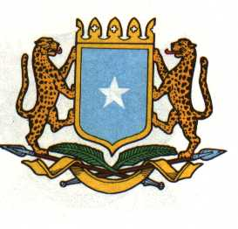 | الفيدرالية ل جمهورية الصوما  البعثة الدائمة لجمهورية الصومال بمكتب الأمم المتحدة بجنيف وبالوكالات المتخصصة بسويسرا
THE FEDERAL REPUBLIC OF SOMALIA
Permanent Mission of the Federal Republic of Somalia to the United Nations Office at Geneva and other International Organizations in Geneva

Statement by the Delegations of Somalia,
Mr. Salah ABUBAKAR, Second Counsellor
At the Review of South Sudan at the 40th session of the UPR Working Group on Monday 31, January from 09:00-12:30 PM, in the Assembly Hall of the Palais des Nations
in Room XX, Geneva.

Thank you, Mr. President,
The Federal Republic of Somalia welcomes the delegation of the Republic of South Sudan and their outstanding country report presented by Hon. Justice Ruben Madol Arol, Minister of Justice and Constitutional Affairs of the Republic of South Sudan.

Somalia appreciates South Sudan’s commitment to make progress on the promotion and protection of Human Rights and continued effort in Cooperation with International, Regional and National mechanisms.

Somalia Recommends the following:

- Strengthen South Sudan’s National Human Rights Commission and its mandate.
- Increase the national budget allocation to the health and education sectors.
- Prioritize under taking consensus to prepare free and fair elections.

We wish the Republic of South Sudan a successful UPR review

I Thank you Chair.

January 31, 2022

