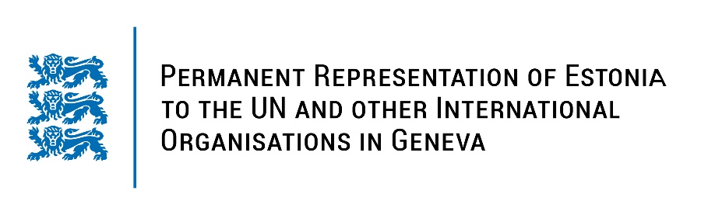
Universal Periodical Review of the Republic of Lithuania
26 January 2022
Intervention by the delegation of Estonia

Estonia warmly welcomes the delegation of the Republic of Lithuania to its third UPR. We thank Lithuania for their report and information provided today.

Estonia notes with appreciation that Lithuania has ratified almost all of the United Nations core human rights instruments and their optional protocols. We are glad to note that protection of children's rights is one of Lithuania’s main priorities during its membership of the Human Rights Council.

Estonia welcomes the accreditation the Seimas Ombudsmen’s Office as a National Human Rights Institution with Status ‘A’ in line with the Paris Principles.

We further welcome Lithuania’s respond to the challenge with asylum seekers, which has increased more than tenfold in 2021, providing additional funding for the protection of their rights and paying particular attention to the vulnerable migrants.

Estonia would like to recommend to the Government of Lithuania to:
- improve the financing of social services and thus assure their the quality, giving priority to childcare facilities;
- implement sustainable policies and measures aimed at employment of persons with disabilities in the open labour market;
- further implement integrated measures for poverty reduction and social inclusion, especially among seniors, people with disabilities, single people, and single parents.

We wish the delegation of Lithuania a successful review meeting.
I thank you!

