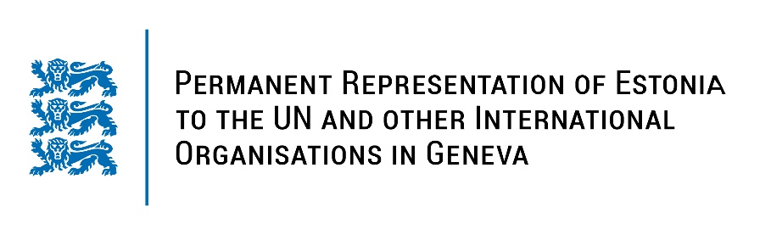
Universal Periodic Review of the Republic of Iceland
25 January 2022
Intervention by the delegation of Estonia

Estonia very warmly welcomes the delegation of the Republic of Iceland to the UPR’s 40th session. We are glad to note that Iceland has been active in the promotion and protection of human rights on both national and international level.

We very much welcome that Iceland has ratified the Council of Europe Convention on preventing and combating violence against women and domestic violence (the Istanbul Convention) and that Iceland has carried out the adoption of the action plan for the prevention of all forms of violence, including domestic violence. We note with appreciation that Iceland has implemented Estonia’s recommendations from the previous UPR cycle.

We appreciate the Government´s ongoing efforts in gender-related issues and commend Iceland for progress made in promoting gender equality, and paying constant attention to the prevention of violence against persons with disabilities, especially women and girls.

Estonia would like to recommend to the Republic of Iceland to:
- conduct awareness-raising campaigns to eliminate gender stereotypes and ensure the engagement of men and boys as a critical tool to promote gender equality;
- improve further the access to justice for women victims of domestic and gender-based violence and provide training in the field of domestic and sexual violence for judges, police, prosecutors and other relevant professionals.

We wish the delegation of Iceland a successful review meeting.

Thank you!

