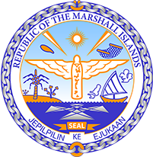

Republic of the Marshall Islands
STATEMENT by H.E Doreen deBrum, Ambassador and Permanent Representative
40th Session, Universal Periodic Review
26 January 2022
Geneva
Zimbabwe

Check against delivery

Thank you, Mister President,

The Marshall Islands welcomes the Delegation of Zimbabwe and thanks them for the presentation of their report.

We commend Zimbabwe on its ambitious target of running a green economy by 2030 and mainstreaming climate change adaptation and resilience into its policy frameworks. We were very pleased to see that the national climate change policy adopted in 2016 included a gender component.

We offer the following recommendations for Zimbabwe ’s consideration:

- Pursue efforts towards abolishing the death penalty;
- Establish an independent complaint system—as provided for in the Constitution—to receive and investigate public complaints against the security services;
- Develop a government plan for eliminating child marriage and amend provisions of the Marriage Act that permit child marriage; and
- Ratify The Convention Against Torture and strengthen efforts to combat torture by enforcing a zero tolerance policy.

We wish the Delegation all success during this UPR cycle.

Kommol tata and I thank you.

