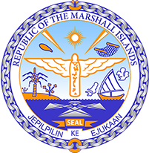

Republic of the Marshall Islands
STATEMENT by Samuel K. Lanwi Jr., Deputy Permanent Representative
40th Session, Universal Periodic Review
24 January 2022
Geneva
Togo

Check against delivery

Thank you, Mister President,

The Marshall Islands warmly welcomes the Delegation of Togo to this UPR cycle and thanks them for their report.

We welcome the recent amendments to the Constitution. In particular, the abolition of the death penalty and life imprisonment were demonstrations of Togo’s commitment to the human right to life.

In the spirit of constructive engagement, the Marshall Islands offers the following recommendations for Togo’s consideration:

- Conduct full and timely investigations on past acts of torture and provide victims with access to effective remedies;
- Release all persons who remain in custody for demonstrating peacefully and exercising their freedom of expression;
- Develop new intervention strategies to eradicate female genital mutilation, including during the COVID-19 pandemic; and
- Amend the Criminal Code to include a specific definition of domestic violence and to align the penalty prescribed for marital rape with that prescribed for rape in general.

In closing, we wish the Delegation of Togo every success during this UPR cycle.

Kommol tata and thank you.

