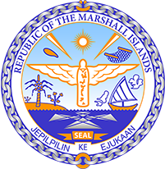

Republic of the Marshall Islands
STATEMENT by Samuel K. Lanwi Jr., Deputy Permanent Representative
40th Session, Universal Periodic Review
27 January 2022
Geneva
Timor-Leste

Check against delivery

Thank you, Mister President,

The Marshall Islands welcomes the Delegation of Timor-Leste and thanks them for the presentation of their report.

We commend Timor-Leste for their promulgation of Law 7/2020 to prevent and combat corruption and the recent approval of the second phase of the national action plan for persons with disabilities.

Likewise, the Marshall Islands is encouraged by Timor-Leste’s effort to end violence against women and girls with the national action plan for gender-based violence and the Spotlight Initiative program, which, among others, has been drawing attention to new challenges brought about by COVID-19. We look forward to seeing the Government taking the necessary measures to further safeguard women’s and girls’ rights.

We offer the following recommendations for Timor-Leste’s consideration:

- Pursue efforts towards the ratification of the Convention on the Rights of Persons with Disabilities;
- Intensify efforts to fully eradicate corporal punishment against children in the home, school and alternative care and day-care settings by explicitly prohibiting it in national legislation; and
- Consider the complete abolition of child marriage by setting the minimum age of marriage for both girls and boys to 18 years of age, without exception.
We wish the Delegation all success during this UPR cycle.

Kommol tata and I thank you.

