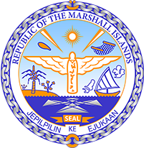

Republic of the Marshall Islands
STATEMENT by H.E Doreen deBrum, Ambassador and Permanent Representative
40th Session, Universal Periodic Review
1 February 2022
Geneva
Sudan

Check against delivery

Thank you, Mister President,

The Marshall Islands welcomes the Delegation of Sudan and thanks them for the presentation of their report.

We commend Sudan’s commitment to the upholding of human rights with the removal of the death penalty for murders committed by children and its signature of the Convention against Torture.

We are also encouraged by its efforts taken as part of the institutional reform with the Separation of the post of Public Prosecutor from the executive branch. With these positive steps, we look forward to seeing the Government taking the necessary measures to strengthen the growing rule of law in the country.

In the spirit of constructive engagement, we offer the following recommendations for Sudan’s consideration:

- Ratify the Convention on the Elimination of All Forms of Discrimination against Women;
- Safeguard the rule of law by upholding the independence of judges; and
- Abolish the death penalty for all crimes without exception.

We wish the Delegation all success during this third UPR cycle.

Kommol tata and I thank you.

