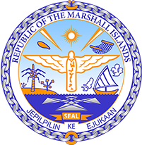

Republic of the Marshall Islands
STATEMENT by H.E Doreen deBrum, Ambassador and Permanent Representative
40th Session, Universal Periodic Review
28 January 2022
Geneva
Republic of Moldova

Check against delivery

Thank you, Mister President,

The Marshall Islands welcomes the Delegation of the Republic of Moldova to this UPR cycle and thanks them for their report.

We celebrate the establishment of the National Human Rights Council along with local level commissions to act as a mechanism for strengthening your commitment to effective implementation of human rights. In addition, the ratification of the Council of Europe’s convention on Preventing and Combating Violence Against Women and Domestic Violence was a necessary step in the fight against gender-based violence.

The Marshall Islands offers the following recommendations for the Republic of Moldova’s consideration:
- Strengthen efforts to include children with special educational needs in the education system, by equipping schools with buses adapted to the needs of children with disabilities;
- Abolish disciplinary solitary confinement for juveniles; and
- Establish facilities and institutions where victims of intimate partner violence, sexual violence and child sexual abuse can find a safe space and be provided government resources to combat the vicious cycle of dependence.

We wish the Delegation of the Republic of Moldova all success during this UPR cycle.

Kommol tata and I thank you.

