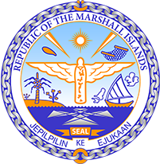

Republic of the Marshall Islands
STATEMENT by H.E Doreen deBrum, Ambassador and Permanent Representative
40th Session, Universal Periodic Review
26 January 2022
Geneva
Lithuania

Check against delivery

Thank you, Mister President,

The Marshall Islands welcomes the Delegation of Lithuania and thanks them for the presentation of their report.

We are encouraged by Lithuania’s efforts to combat domestic violence by adopting the National Programme for the Prevention of Domestic Violence and approving the Specialized Assistance Centre programme

Likewise, the Marshall Islands commends the recent endeavors to address climate change with the adoption of the National Climate Change Management Agenda and the National Energy and Climate Action Plan. We welcome the Government’s commitment to reduce their greenhouse gas emissions by 85-percent by 2040 and a 100-percent reduction by 2050.

With a view to further improve the human rights situation in the country and in the spirit of constructive engagement, we offer the following recommendations for Lithuania’s consideration:

- Operationalize the national Action Plan on the Promotion of Non-discrimination by dedicating adequate funding and establishing apprehensible strategic goals, and effective measures; and
- Pursue efforts to combat gender-based violence by strengthening the legal framework for the protection of women against violence and increasing funding to special assistance centres.

We wish the Delegation all success during this UPR cycle.

Kommol tata and I thank you.

