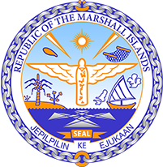

Republic of the Marshall Islands
STATEMENT by H.E Doreen deBrum, Ambassador and Permanent Representative
40th Session, Universal Periodic Review
25 January 2022
Geneva
Iceland

Check against delivery

Thank you, Mister President,

The Marshall Islands welcomes the Delegation of Iceland to this UPR cycle and thanks them for their report.

We welcome the ratification of the main international human rights treaties and efforts in promoting human rights for everyone. In particular, the ratification of the Council of Europe’s convention on Preventing and Combating Violence Against Women and Domestic Violence was a necessary step in the fight against gender-based violence.

In the spirit of constructive engagement, we offer the following recommendations for Iceland’s consideration:
- Guarantee independence, impartiality, publicity, and transparency to the appointments process of judges in order to protect civil and political rights; and
- Ensure adequate funding for the investigation and prosecution of sexual offenses and domestic violence to ensure the rights of women.

We wish the Delegation of Iceland all success during this UPR cycle.

Kommol tata and thank you

