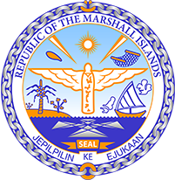

Republic of the Marshall Islands
STATEMENT by Samuel K. Lanwi Jr., Deputy Permanent Representative
40th Session, Universal Periodic Review
31 January 2022
Geneva
Haiti

Check against delivery

Thank you, Mister President,

The Marshall Islands welcomes the Delegation of Haiti and thanks them for the presentation of their report.

We commend Haiti for the effectiveness of the National Plan for the Elimination of Cholera in the country, with no cases having been detected for the last three years. Moreover, the Marshall Islands welcomes Haiti’s efforts in respect to environmental protection with the signature of the Escazú Agreement. We are looking forward to seeing the Government taking the necessary measures to ratify this agreement and give it full legal effect.

However, we are concerned that recent events in the country could potentially further undermine the budding rule of law.

We offer the following recommendations for Haiti’s consideration:

- Pursue efforts in the fight against impunity with the ratification of the Rome Statute of the International Criminal Court and institutional reforms ensuring the complete independence of the judiciary from the executive branch;
- Ratify the Convention against Torture; and
- Consider the complete abolition of child marriage by setting the minimum age of marriage for both girls and boys to 18 years of age, without exception.

We wish the Delegation all success during this UPR cycle.

Kommol tata and I thank you.

