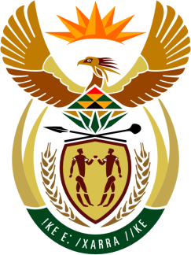

SOUTH AFRICAN PERMANENT MISSION

40th SESSION OF THE WORKING GROUP ON THE
UNIVERSAL PERIODIC REVIEW

Review of THE BOLIVARIAN REPUBLIC OF VENEZUELA

25 JANUARY 2021
(14:30-18:00)

VIRTUAL (ZOOM PLATFORM)
(55 seconds)

Check against delivery

Mister President,

South Africa extends fraternal greetings and a warm welcome to the Honourable Vice President, Madame Delcy Rodríguez, and the distinguished delegation of the Bolivarian Republic of Venezuela to its 3rd review under the UPR mechanism during this Session.

My delegation welcomes the Government’s efforts and commitment to combating inequality and reduce poverty.

In order to ensure progress in promoting and protecting human rights, South Africa wishes to respectively recommend that Venezuela:

- Fully implement the “Mama Rosa” Gender Equality and Equity Plan, 2019 to 2025.

- Continue efforts aimed at reforming the prison system in line with the Nelson Mandela Rules.

South Africa wishes Venezuela a successful review.

I thank you.

