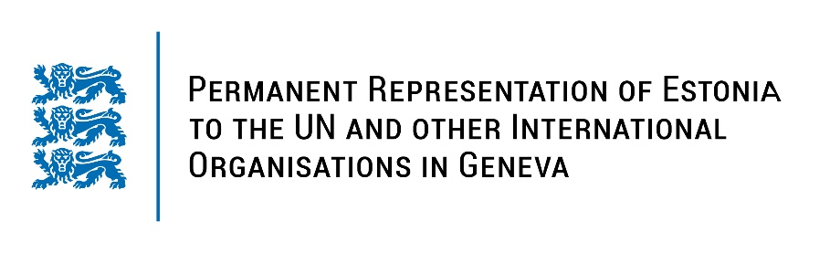
Universal Periodic Review of the Republic of the Sudan
2 February 2022
Intervention by the delegation of Estonia

Estonia will continue to support the democratic transition in Sudan and call for the immediate holding of the general election in a free, fear and inclusive manner.

We would like to stress the importance of monitoring carefully the situation of human rights in Sudan, especially in the view of resolution from November 2021. In this respect, we hope for the appointment of special rapporteur soon.

We note with concern that reform efforts in Sudan are lacking adequate community participation and public debate about ongoing reform processes has been very limited. We are worried about the use of violence by the authorities during recent street protests and the inability to reach the agreement on the formation of the government inclusive of all stakeholders.

Estonia would like to recommend to:
- abolish death penalty;
- prioritise the protection of women from violence by reforming or repealing state legislation;
- accelerate the formation of the Commission for Women and Gender Equality and the Commission for Legal Reform;
- modify the legislation to ensure freedom of expression and press.

We wish Sudan a successful review meeting. Thank you!

