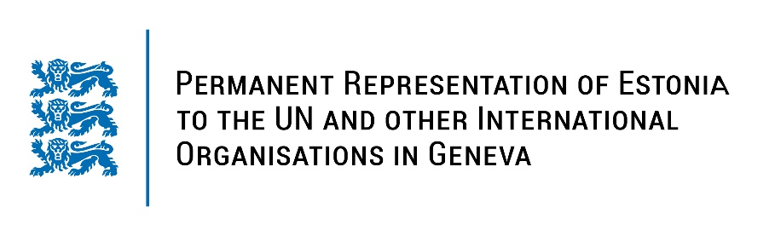
Universal Periodic Review of the Republic of South Sudan
31 January 2022
Intervention by the delegation of Estonia

Estonia welcomes the delegation of the Republic of South Sudan to this UPR session.

Estonia notes that there is a political will to prepare for the elections at the end of the transitional period. We welcome the steps taken to have all stakeholders signing the ceasefire agreement and reported progress in the establishment of a transitional justice mechanism.

At the same time, Estonia is concerned about the continuous deterioration of humanitarian situation
in South Sudan.

Estonia would like to recommend to the Government of South Sudan to:

- adopt a comprehensive law addressing all forms of violence against women and girls and eradicate the harmful practice of early and forced marriage;
- implement the comprehensive action plan to end and prevent violations against children;
- protect human rights defenders and journalists from violence and arbitrary arrests, and address impunity for crimes against human rights defenders and journalists.

Estonia would like to wish the delegation of South Sudan a successful review meeting. I thank you!

