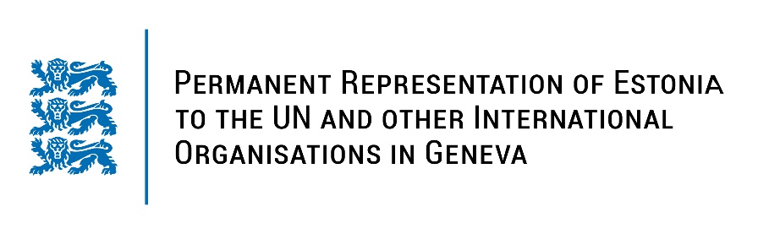
Universal Periodical Review of the Republic of Moldova
28 January 2022
Intervention by the delegation of Estonia
Estonia warmly welcomes the delegation of the Republic of Moldova and thanks for the report and the information provided today.

We positively note the adoption of the National Human Rights Action Plan 2018-2022 and the efforts of Moldova to implement the recommendations given in the previous UPR cycle.

Estonia appreciates the steps taken towards achieving gender equality and fight against domestic violence. We welcome the ratification of the Istanbul Convention (the Council of Europe Convention on preventing and combating violence against women and domestic violence) and adoption of Action Plan on the Implementation of UNSC resolution 1325.

We deeply regret to note that the human rights situation in Transnistria has sharply worsened. The entities in control of the region have used Covid-19 as rationale for serious and systematic violations. We encourage strengthening the dialogue on human rights issues on bilateral level as well as within international human rights mechanisms.

We would like to recommend to the Government of the Republic of Moldova to:
- take steps to ensure that justice reforms and reforming of court system guarantees independence of the judiciary and creates equal access to justice, including to human rights cases;
- ratify the Kampala Amendments to the Rome Statute of the ICC and the Agreement on Privileges and Immunities of the Court;
- develop a new civil society strategy to support the development of civil society and involve them in the decision-making process in line with international democratic standards.

We wish the delegation of the Republic of Moldova a successful review meeting. Thank you!

