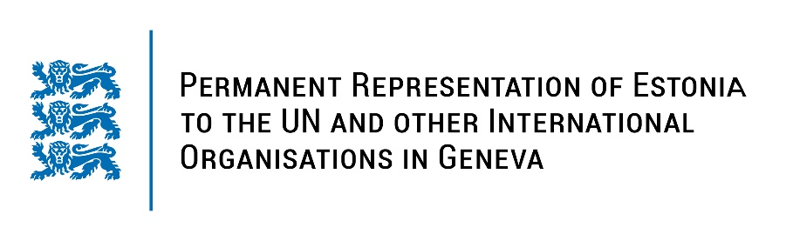
Universal Periodic Review of the Republic of Uganda
27 January 2022
Intervention by the delegation of Estonia

Estonia welcomes the delegation of the Republic of Uganda to this UPR session.

We would like to commend Uganda for the steps taken since the previous UPR, including for submitting reports to treaty bodies.

However, Estonia is concerned that the attacks on civic space have continued and escalated during the recent electoral period, human rights defenders face the threat of arrest and freedom of expression is also undermined.

Estonia would like to recommend to the Government of Uganda to:
- abolish death penalty and ratify the Second Optional Protocol to the International Covenant on Civil and Political Rights (ICCPR);
- ratify the Optional Protocol of the Convention against Torture and Other Cruel, Inhuman or Degrading Treatment or Punishment (OP-CAT);
- rise dramatically public expenditure for education and reduce the share of child labor;
- radically improve the social, educational and economic rights of women and girls;
- work on specific legislative measures to end the harassment of human rights defenders, civil society actors and journalists;
- remove all obstacles to the right to freedom of expression and media freedom.

Estonia would like to wish the delegation of Uganda a successful review meeting.
I thank you!

