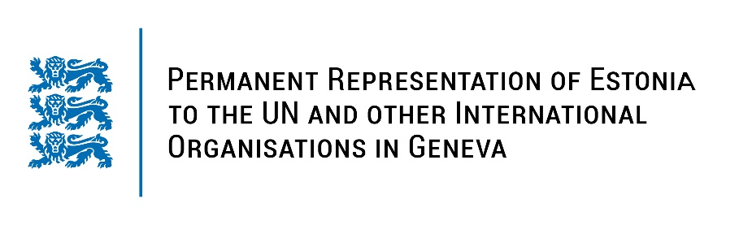
Universal Periodic Review of the Bolivarian Republic of Venezuela
25 January 2022
Intervention by the delegation of Estonia

Estonia welcomes the fact that the Bolivarian Republic of Venezuela has prepared the national report and provided the additional information today.

We are deeply concerned that since the previous UPR in 2016 the human rights situation in Venezuela has seriously deteriorated in the context of the ongoing political, social, economic and humanitarian crisis.

Estonia notes positively an OHCHR presence in the country, which has allowed to monitor and document the human rights situation more closely and to engage in technical cooperation with the authorities.

Estonia recommends to the Bolivarian Republic of Venezuela to:

- improve the situation of civil and political rights, respect for human rights and fundamental freedoms and annul restrictions to civic and democratic space;
- create a safe non-discriminatory environment for the press, civil society and humanitarian organizations and ensure the safety of people working in these areas;
- ensure guarantees of a fair trial and compliance with constitutional requirements;
- ratify the Optional Protocol of the Convention against Torture and Other Cruel, Inhuman or Degrading Treatment or Punishment (OP-CAT).

I thank you.

