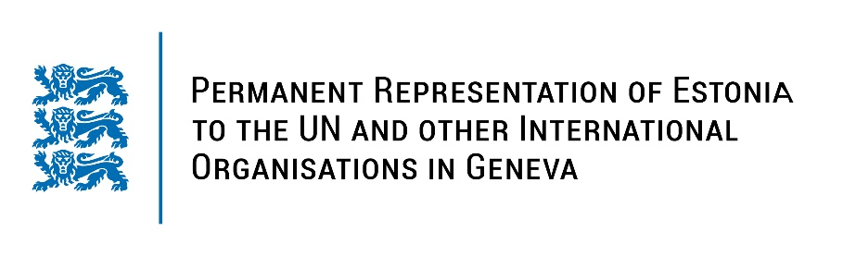
Universal Periodic Review of the Syrian Arab Republic
24 January 2022
Intervention by the delegation of Estonia

Estonia welcomes the delegation of the Syrian Arab Republic to this UPR session. Estonia welcomes the fact that the Syrian Arab Republic has prepared the national report and provided the additional information today.

We regret that despite relevant accepted UPR2 recommendations several new laws have not been implemented and that Syria has not ratified any new human rights treaties or protocols.

Estonia is gravely concerned that the Government of the Syrian Arab Republic has failed to cooperate fully with the UN-mandated Independent International Commission of Inquiry to assist in investigation and prosecution for the most serious crimes committed in Syria since 2011.

We would like to recommend to the Government of the Syrian Arab Republic to:
- ensure immediate, full and unhindered access of humanitarian aid all over its the territory;
- release all political detainees, immediately end torture and other forms of ill-treatment, grant relevant impartial organisations access to all detention facilities;
- investigate International Human Rights and International Humanitarian Law violations and prosecute perpetrators;
- remove from the relevant laws the provisions that are discriminatory towards women.

I thank you.

