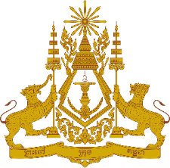
PERMANENT MISSION OF THE KINGDOM OF CAMBODIA
TO THE UNITED NATIONS AT GENEVA

Statement of Cambodia
At the 40th Session of the UPR Working Group
UPR of the Bolivarian Republic of Venezuela
25 January 2022
-------
Mr. President!

- Cambodia recognizes the Bolivarian Republic of Venezuela’s extensive endeavours to continue to engage with the UN human rights mechanism and special procedures.

- We also commend Venezuela’s efforts and achievements in addressing impact of the Covid-19 pandemic upon most vulnerable groups. Its investment in education system, universal health coverage and health services delivery are also recognized.

- In the constructive spirit, Cambodia would like to put forward the following recommendations:

- Continue to intensify the ongoing efforts toward inclusive economic growth and further poverty reduction, and;
- Continue endeavours to increase women’s participation in public affairs and economic development.

- Finally, I wish the delegation of the Bolivarian Republic of Venezuela every success in this exercise.

I thank you.
*****

