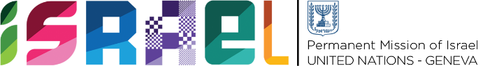 | Check against delivery  1 minute 30 secs

Statement on behalf of the State of Israel
UPR Working Group - 40th Session

Review of Moldova

Ambassador Meirav Eilon Shahar
Permanent Representative of Israel to the United Nations in Geneva

Thank you, Mr. President.

Israel warmly welcomes the delegation of Moldova and thanks them for their National Report.
Israel would like to welcome the adoption of the International Remembrance Holocaust Alliance (IHRA) working definition of antisemitism and the approval of the Action Plan for 2021-2025 to promote Holocaust remembrance and the culture of tolerance. However, Israel remains concerned about the rise of antisemitism. Therefore Israel recommends Moldova to:

- Further enhance its efforts to combat all forms of antisemitism, including through the full implementation of the International Holocaust Remembrance Alliance working definition of antisemitism, in policy and in practice.
We would also like to congratulate Moldova for its ratification of the Istanbul Convention, and in this regard, recommend Moldova to:

- Fully implement the Istanbul Convention into domestic laws and policies, to protect and support victims
Israel also recognizes that prevention and combating of trafficking in persons is a priority for Moldova, and therefore recommend Moldova to:
- Continue measures to prevent and combat trafficking in persons in accordance with international standards.
I thank you, Mr President

