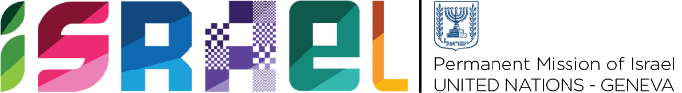 | Check against delivery  1 minute 15 secs

Statement on behalf of the State of Israel
UPR Working Group – 40th Session

Review of Lithuania

Ambassador Meirav Eilon Shahar
Permanent Representative of Israel to the United Nations in Geneva
Thank you, Mr. President.

Israel warmly welcomes the delegation of Lithuania and thanks them for their National Report.

Israel would first like to commend Lithuania for including Youth and young people in decision-making levels, including through the Youth Council and the Department of Youth Affairs.

We also welcome the 2021-2023 Action Plan for the Promotion of Non-Discrimination. We recognize that Lithuania has made important progress towards ensuring LGBTQI+ persons’ full and equal enjoyment of human rights.

In this regard, Israel recommends Lithuania:

- Consider adopting the gender-neutral Partnership law proposed by the coalition parties in government.
We are concerned about the increase in misrepresentation of facts about the Holocaust and the rise of antisemitism in Lithuania, but commend the government for taking measures to address this including adopting the IHRA Working Definition of Antisemitism.
In this regard, Israel recommends Lithuania to:

- Strengthen formal and informal holocaust education to combat the rise of antisemitism.

Thank you Mr. President.

