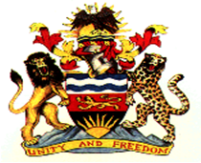
REPUBLIC OF MALAWI
MALAWI STATEMENT ON UNIVERSAL PERIODIC REVIEW OF UGANDA
27 JANUARY 2022
Delivered by Pacharo Kayira, Deputy Permanent Representative
- Malawi warmly welcomes Uganda to this review and we take note of the progress the country has made in the promotion and protection of human rights.
- Malawi makes the following recommendations:
  - Continue to take steps in the protection of the girl child against vices such as early marriages, human trafficking and sexual exploitation
  - Continue to take steps to increase women representation in political and public offices.
  - Develop an implementation plan for the systematic implementation of recommendations from this review process
Weebale, Thank you

