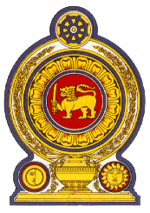

40th Session of the Universal Periodic Review

Review of the Syrian Arab Republic– 24 January 2022

Statement by the Democratic Socialist Republic of Sri Lanka

Mr. President,

Sri Lanka welcomes the delegation of the Syrian Arab Republic and appreciates the presentation made.

We commend Syria’s efforts to improve the human rights situation in the country which includes measures taken to combat terrorism and provision of humanitarian aid to displaced persons. We also recognize Syria’s implementation of the national development programme for post war Syria– that includes programmes for social security and a psychosocial support programme.

We acknowledge the challenges faced by Syria for many years due to interventions and conflicts which have been compounded by the application of unilateral coercive measures. We commend Syria for the measures taken to ensure respect for the fundamental rights of citizens within the means available.

While recognizing the progress already made, in a constructive spirit Sri Lanka recommends that Syria:

- Further promotes physical and mental rehabilitation of victims of child recruitment;

- Increase efforts towards human rights related training programmes for the justice sector; and

- Further advances right to health including national vaccination programmes for children.

We wish the Syrian Arab Republic success in its UPR engagement.

