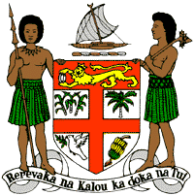
PERMANENT MISSION OF THE REPUBLIC OF FIJI TO THE UNITED NATIONS
OFFICE AND OTHER INTERNATIONAL ORGANISATIONS AT GENEVA
40TH SESSION OF THE UPR WORKING GROUP
UGANDA
Fiji welcomes the delegation of Uganda and commends the Government for its efforts to finalise its national action plan on human rights and the advances made in increasing access to health services.
Fiji offers the following recommendations:
- Strengthen efforts to ensure the participation of women, children, persons with disabilities and local communities when developing and implementing climate change and disaster risk reduction frameworks.
- Strengthen efforts to address violence against women, children and against all persons on the basis of their sexual orientation and gender identity, including measures to prevent violence and support survivors.
- Increase investment in the health system and infrastructure and ensure improvement in the equitable distribution and availability of sexual reproductive health and child care services.
- Strengthen efforts to ensure the effective investigation, prosecution and punishment for all acts of torture and ill-treatment, and provide access to justice and rehabilitation to victims of torture.
We wish the delegation of Uganda a successful review. I thank you.

