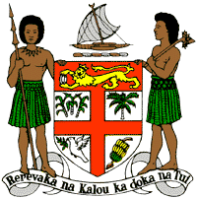
PERMANENT MISSION OF THE REPUBLIC OF FIJI TO THE UNITED NATIONS
OFFICE AND OTHER INTERNATIONAL ORGANISATIONS AT GENEVA
40TH SESSION OF THE UPR WORKING GROUP
TOGO
Fiji welcomes the delegation of Togo and commends the government for the establishment of a multi-stakeholder platform for collaboration between the Government, its National Human Rights Commission and other stakeholders to exchange information on human rights issues. This speaks to the commitment and determination of the Government of Togo in protecting and promoting the human rights of its people.
Fiji offers the following recommendations:
- Intensify efforts to develop and strengthen the necessary legislative frameworks that address cross-sectoral environmental challenges, including climate change and disaster risk reduction frameworks.
- Strengthen efforts to address violence against women, children and against all persons on the basis of their sexual orientation and gender identity, including measures to prevent violence and support survivors, as well as by removing obstacles that prevent access to justice.
- Allocate the necessary human, technical and financial resources to effectively implement its policies and procedures to combat trafficking in persons, with a focus on trafficking of women and children.
We wish Togo a successful review.

