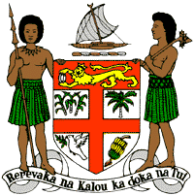
PERMANENT MISSION OF THE REPUBLIC OF FIJI TO THE UNITED NATIONS
OFFICE AND OTHER INTERNATIONAL ORGANISATIONS AT GENEVA
40TH SESSION OF THE UPR WORKING GROUP
TIMOR-LESTE
Fiji welcomes the delegation of Timo-Leste and commends the Government on its commitment to the protection and promotion of human rights, including through the development of its national action plan on gender-based violence, its national action plan on zero hunger, its action plan for women, peace and security, its national action plan on the rights of the child and its national action plan for disables persons. Timo-Leste’s focus on equality and non-discrimination, access to justice and services for victims of sexual and domestic violence showcases the integration of a holistic approach to addressing human rights.
Fiji offers the following recommendations:
- Strengthen efforts to guarantee the participation of women, children, persons with disabilities and local communities when developing and implementing climate change and disaster risk reduction policies.
- Strengthen efforts to address violence against women, children and against all persons on the basis of their sexual orientation and gender identity, including measures to prevent violence and support survivors, as well as by removing obstacles that prevent access to justice.
- Increase investment in the necessary human, technical and financial resources to strengthen and improve the education system and infrastructure, and provide human rights training to teachers.
We wish Timor-Leste a successful review. I thank you.

