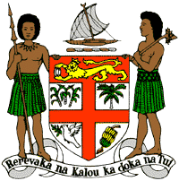
PERMANENT MISSION OF THE REPUBLIC OF FIJI TO THE UNITED NATIONS
OFFICE AND OTHER INTERNATIONAL ORGANISATIONS AT GENEVA
40TH SESSION OF THE UPR WORKING GROUP
REPUBLIC OF MOLDOVA
Fiji welcomes the delegation of the Republic of Moldova and commends the Government for the implementation of the recommendations from its previous cycle. Fiji welcomes the establishment of the National Human Rights Council and the adoption of its National Human Rights Action Plan. The combination of responding to recommendations raised by the UPR and establishing the requisite body and framework to give effect to its human rights obligations and commitments, are commendable.
Fiji offers the following recommendations:
- Intensify efforts to develop and strengthen the necessary legislative frameworks that address cross-sectoral environmental challenges, including climate change adaptation and disaster risk reduction frameworks.
- Strengthen efforts to ensure that persons with disabilities have access to health, education and social services and ensure their full integration in society.
- Implement the UN Basic Set of Rules for the Treatment of Prisoners (Nelson Mandela Rules) to improve conditions of detention.
- Strengthen efforts to eliminate discrimination and violence based on sexual orientation and gender identity, actual or perceived, in compliance with its human rights obligations.
We wish the Republic of Moldova a successful review. I thank you.

