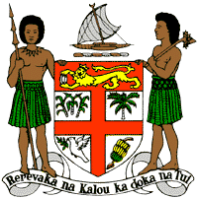
PERMANENT MISSION OF THE REPUBLIC OF FIJI TO THE UNITED NATIONS
OFFICE AND OTHER INTERNATIONAL ORGANISATIONS AT GENEVA
40TH SESSION OF THE UPR WORKING GROUP
REPUBLIC OF HAITI
Fiji welcomes the delegation of the Republic of Haiti and commends it for its continued engagement through the UPR process. As a fellow Small Island Developing State, Fiji understands the human rights challenges arising with the increasingly adverse impacts of climate change and natural disasters, and commends Haiti for its resilience and continued commitment to the protection and promotion of human rights.
Fiji offers the following recommendations:
- Intensify efforts to develop and strengthen the necessary legislative frameworks that address cross-sectoral environmental challenges, including climate change adaptation and disaster risk reduction frameworks.
- Ratify the Convention against Torture and Other Cruel, Inhuman or Degrading Treatment or Punishment.
- Intensify efforts to address violence against women, children and against all persons on the basis of their sexual orientation and gender identity, including measures to prevent violence and support survivors, as well as by removing obstacles that prevent access to justice.
- Continue to strengthen efforts to improve access to health care for all, including access to sexual and reproductive health-care services and information.
We wish the Republic of Haiti a successful review.

