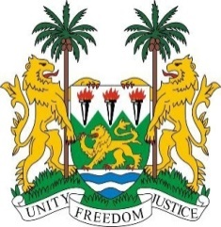
SIERRA LEONE
40th Session of the UPR (24 January – 4 February 2022)

UPR Review of Zimbabwe

26 January 2022

Mr President,
Sierra Leone extends a cordial welcome to the Zimbabwean delegation and thanks them for their presentation.
My delegation commends the Government of Zimbabwe for the promulgation of the International Treaties Act in 2020 for the efficient ratification of international treaties. We also commend the adoption of the National Health Strategy for Zimbabwe (2016-2020) to improve public health and to achieve health equity.

Sierra Leone welcomes steps taken to review domestic laws to align them with the Constitution, particularly the Criminal Law (Codification and Reform) Act which criminalises acts that constitute elements of torture and cruel treatment. However, we regret that our recommendation to ratify the Convention Against Torture was noted.
Furthermore, my delegation welcomes the strides taken by the Government towards child rights, especially the establishment of child protection systems.
In a constructive spirit, Sierra Leone makes the following recommendations:
- Ratify the CAT, ICRMW, ICPPED, Optional Protocol to ICESCR, and the Second Optional Protocol to ICCPR
- Amend the Constitution to abolish the death penalty for all crimes
- Amend the provisions of the Marriage Act which permits child marriage, in line with the decision of the Constitutional Court
- Enhance efforts to integrate international obligations into the Constitution and national laws

To conclude, Sierra Leone wishes Zimbabwe a successful review outcome.

Thank you, Mr President
(Speaking time allocated: 1 minute and 5 seconds)

