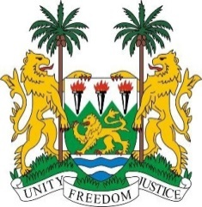
SIERRA LEONE
40th Session of the UPR (24 January – 4 February 2022)

UPR Review of Uganda

27 January 2022

Mr President,
Sierra Leone warmly welcomes the delegation of Uganda to the third cycle UPR and thanks them for the presentation of their national report.
My delegation commends the government for the adoption of legislation and strategies to support the rights of children, including the National Child Policy, the National Social Protection Policy, and the National Strategy for ending Child Marriage and Teenage Pregnancy. We encourage the government to expedite the effective implementation of these polices.
Sierra Leone also commends Uganda for its achievements in the fight against HIV/AIDS, as well as its commitment to incorporating a human rights-based approach into its implementation of the 2030 Agenda for Sustainable Development.
In a constructive spirit, Sierra Leone makes the following recommendations:
- Ratify and accede to the ICPPED, the CRPD, and other international human rights treaties to which the country is not yet party

- Expedite the implementation of the National Transitional Justice Policy

- Thoroughly investigate acts of torture and excessive use of force by the police, to ensure that perpetrators of violations are brought to justice

- Commute all death sentences with a view to formally abolish the death penalty

To conclude, Sierra Leone wishes Uganda every success in completing this UPR session.
Thank you, Mr President

(Speaking time allocated: 1 minute and 5 seconds)

