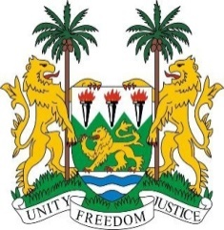
SIERRA LEONE
40th Session of the UPR (24 January – 4 February 2022)

Universal Periodic Review of Togo

24th January 2022

Mr. President,

Sierra Leone extends a warm welcome to the delegation of Togo and thanks the country for its detailed report and engagement with the UPR process.
Sierra Leone commends the new measures taken to advance the rights of women and children in Togo, including the National Programme to Prevent Adolescent Pregnancies and Child Marriage and measures taken to combat gender-based and other forms of violence against women.

Sierra Leone notes the codification of the abolition of the death penalty into the National Constitution of Togo. My delegation welcomes the implementation of our previous recommendation to ratify the International Convention on the Protection of the Rights of All Migrant Workers and Members of Their Families.

In a constructive Spirit, Sierra Leone recommends that Togo:

- Address the issue of prison overcrowding to ensure prisoners’ human rights

- Expedite the process of accession of the 1954 Convention relating to the Status of Stateless Persons and the 1961 Convention on the Reduction of Statelessness

- Develop and support programs aimed at providing women and girls equal access to decision making bodies, educational and economic opportunities.

- Enact law to remove gender discrimination from its nationality legislation.

- Ratify the Optional Protocol CEDAW

We wish Togo every success in this UPR process.

I thank you.

(Speaking time allocated: 1 minute and 10 seconds)

