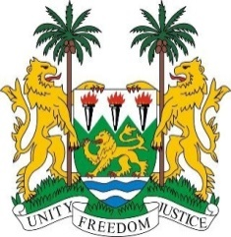
SIERRA LEONE
40th Session of the UPR (24 January – 4 February 2022)

UPR Review of Sudan

1 February 2022

Mr. President,
Sierra Leone welcomes the delegation of Sudan and thanks them for the presentation of their national report.
My delegation commends the government for ratifying the Convention Against Torture, as well as for abolishing all forms of corporal punishment and the death penalty for children and for ta’zir offences. We also commend the adoption of a national strategy and update of the national action plan to end child marriage in Sudan.

Sierra Leone welcomes various steps taken to promote women’s rights, including the emphasis on women’s rights provisions in the constitutional document and the formation of independent Unit to Combat Violence Against Women.

In a constructive spirit, Sierra Leone makes the following recommendations to Sudan:
- Ratify the CEDAW and the Second Optional Protocol to ICCPR aiming at the abolition of the death penalty.

- Establish an independent National Human Rights Commission as per the Paris Principles.

- Consider to amend its legislation in order to set the minimum age of marriage at 18 years.

- Establish human rights and accountability-based reconciliation mechanisms in to prevent and resolve intercommunal conflicts.

Sierra Leone wishes Sudan a successful UPR.

Thank you, Mr President

(Speaking time allocated: 1 minute and 5 seconds)

