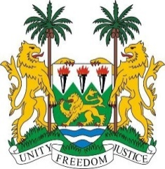
SIERRA LEONE
40th Session of the UPR (24 January – 4 February 2022)

UPR Review of South Sudan

31 January 2022
Mr President,
Sierra Leone welcomes the delegation of South Sudan and thanks them for the presentation of their national report.
My delegation commends the government for signing the Revitalized Agreement on the Resolution of the Conflict. We call on all parties to continue to actively engage in a peaceful resolution to the conflict.
My delegation particularly welcomes the actions taken to promote the rights of children, particularly the accession of the Convention of the Rights of the Child and the reunification of over 1,200 children found among opposition forces with their families.
In a constructive spirit, Sierra Leone makes the following recommendations:
- Ratify and accede to ICCPED, ICESCR, ICCPR and other core international human rights treaties and conventions yet to be ratified.

- Enact legislation on child marriage in accordance with international human rights laws

- Allocate resources to implement policies and concrete enforcement measures to further protect women and girls, and to strengthen the administration of justice

- Strengthen transitional justice by establishing the three transitional justice mechanisms named in the peace agreement.

Sierra Leone wishes South Sudan a successful review.
Thank you, Mr President
(Speaking time allocated: 1 minute and 15 seconds)

