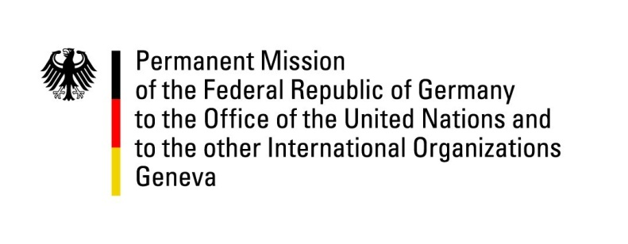

United Nations Human Rights Council

40th Session of the UPR Working Group

Geneva, 26th of January 2022

German Recommendations to

Zimbabwe

Mister Vice- President,
Germany commends Zimbabwe for having ratified the African Charter for Democracy, Elections and Governance.
However, Germany remains concerned about arbitrary arrests and prosecution of opposition members and civil society activists.

Germany therefore recommends:
- to ratify the UN Convention against Torture and other Cruel, Inhuman or Degrading Treatment or Punishment.
- to accelerate the process of aligning national legislation with the legal standards and requirements of Zimbabwe’s Constitution, especially the Electoral Act, the Criminal Law Act and the Marriage Act.
- to adopt measures to make progress on the elimination of all forms of discrimination against people on the basis of their sexual orientation and gender identity.
- to end impunity for human rights violations and follow up the recommendations made by the Motlanthe Commission on the issue of individual responsibility.
Thank you.

