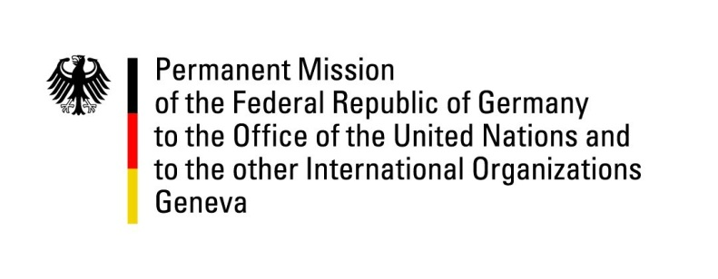

United Nations Human Rights Council

40th Session of the UPR Working Group

Geneva, 27th of January 2022

German Recommendations to
Uganda

Mister Vice-President,
Germany welcomes the delegation of Uganda and its constructive engagement in the UPR. Germany commends that Uganda has filled important positions at the Uganda Human Rights Commission that Germany actively supports in its bilateral cooperation.

Germany recommends Uganda to:
- To take strong measures to promote children´s right to education after long periods of school closures;
- To ensure effective investigations, prosecutions and sanctions with respect to widespread allegations of arbitrary detentions in the course of last year´s elections as well as allegations of torture and extrajudicial killings by security forces and to inform the general public on the outcomes of these investigations;
- To abstain from unduly restricting the work of nongovernmental organizations
- To improve access to justice for victims of gender based violence

Thank you.

