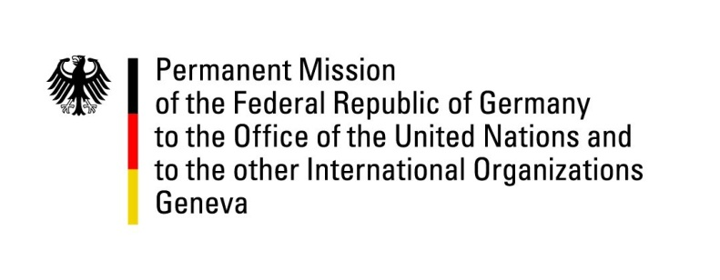

United Nations Human Rights Council

40th Session of the UPR Working Group

Geneva, 24th of January 2022

German Recommendations to

Togo

Mister President,
on the occasion of this first UPR session of the year, we want to wish you good luck and are looking forward to your leadership of the council.
Germany welcomes the delegation of Togo and commends Togo for decentralization efforts, efforts to improve prison conditions and the national mechanism on torture prevention.

However, Germany remains concerned about the protection of human rights defenders, impunity of security forces and restrictions on the freedoms of expression, association and assembly.

Germany therefore recommends to:
- further improve prison conditions, including by considering alternative sentences and by improving medical and sanitary conditions
- involve relevant civil society actors in the elaboration of legislation on human rights defenders and to establish their legal recognition
- improve the legislative protection of women against violence and discrimination
- adopt and implement legislation to protect and facilitate the work of journalists and bloggers.
Thank you, Mister President.

