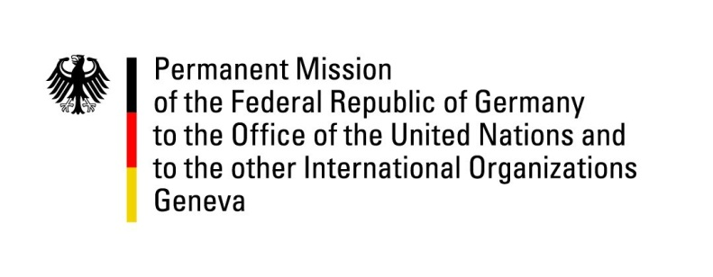

United Nations Human Rights Council

40th Session of the UPR Working Group

Geneva, 28th January 2022

German Statement

Moldova

Mister President,
Germany welcomes the delegation of Moldova to the UPR. We commend Moldova for progress made with regard to combatting corruption and for the reform of the justice system as well as for the ratification of the Istanbul Convention.
However, we remain concerned about detention management and conditions in prisons.
Germany recommends to:
- Ensure that all complaints of acts of torture and ill-treatment in the penitentiary system are promptly, impartially and effectively investigated in accordance with international human rights standards, including the Istanbul Protocol.
- Implement the recommendations of the 2020 European Committee for the Prevention of Torture and Inhuman or Degrading Treatment or Punishment (CPT).
- Improve conditions in prisons and take effective measures against overcrowding in line with international standards, including with the Nelson Mandela rules.
- Adopt legislation to ensure remedies, access to justice and rehabilitation for victims of torture and ill-treatment.

Thank you, Mister President.

GERMAN ADVANCE QUESTIONS TO Moldova:

- Which measures does Moldova take to combat overcrowding in prisons and to lower the incarceration rate?

- How does Moldova ensure that victims of torture and ill-treatment have adequate access to justice and rehabilitation? What is the time frame for implementing these measures?

- How does Moldova follow up on the 2020 visit of the European Committee for the Prevention of Torture and Inhuman or Degrading Treatment or Punishment (CPT) and implement the recommendations of the report?

