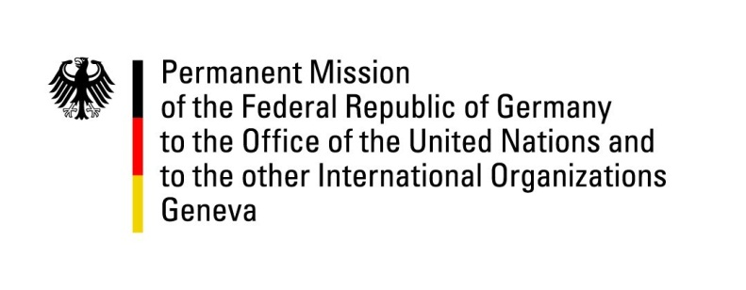

United Nations Human Rights Council

40th Session of the UPR Working Group

Geneva, 25th of January 2022

German Recommendations and advance questions to

Venezuela

Mister President,
Germany welcomes the delegation of Venezuela, acknowledges the small OHCHR presence in Caracas and notes the permission of World Food Program activities in 2021.

However, it is concerning that our recommendation from the last cycle to, inter alia, safeguard freedom of opinion and expression [,which was supported by Venezuela,] has not been sufficiently implemented.

Germany therefore recommends to:
- Guarantee the independence and impartiality of the judiciary and the rule of law, including by observing the existing rules for court hearings and reviews of remand orders.
- Intensify international cooperation for the protection of human rights, including by allowing a staff expansion at the OHCHR office in Caracas and granting effective access to the country.
- Allow for the expansion of the operation of humanitarian organizations like the World Food Program and ensure a safe environment for their work
- Allow the UN’s Fact Finding Mission to operate in Venezuela.

Thank you, Mister President.
GERMAN ADVANCE QUESTIONS TO Venezuela:
- Javier Tarazona, the Director of the NGO Fundaredes, remains one of 243 political prisoners, according to the NGO Foro Penal. His health is rapidly deteriorating while being arbitrarily detained. What is being done by Venezuela to ensure minimum treatment rules for prisoners are being respected?

- The High Commissioner for Human Rights recommended to dissolve the Fuerzas de Acciones Especiales (FAES), but noted in HRC 42 that the FAES continue to receive support from the highest level of government. Which – if any – steps have been taken to dissolve the FAES?

- International organizations, including FAO, are alarmed by food insecurity in Venezuela: When will Venezuela publish related data as a first step to address the problem?

- Noting that in the past years only one special rapporteur was granted access to Venezuela while many others have requested access without it having been granted, including the Special Rapporteurs on torture, freedom of association and assembly as well as on the human rights to safe drinking and sanitation: When will these requests be approved?

