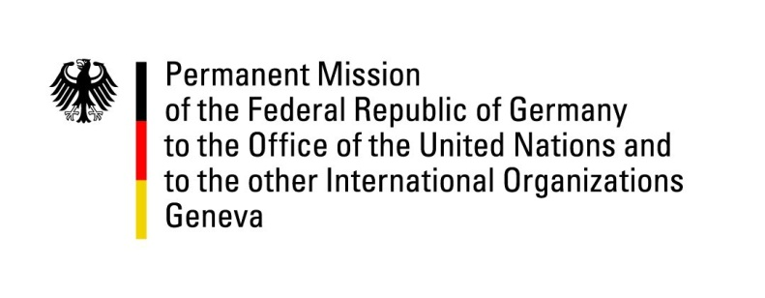

United Nations Human Rights Council

40th Session of the UPR Working Group

Geneva, 31th of January 2022

German Recommendations and advance questions to

South Sudan

Mister President,
Germany welcomes the delegation of South Sudan and commends South Sudan for progress achieved in implementing the peace agreement (R-ARCSS) including establishing legislative organs.

However, Germany remains concerned about intercommunal violence, including gender based violence, and the distressing humanitarian situation that has been exacerbated by conflicts and the devastating floods of 2021.

Germany therefore recommends to:
- Establish the institutions for Transitional Justice as laid down in Chapter 5 of the peace agreement. The technical committee for the establishment of the Commission for Truth, Reconciliation and Healing (CTRH) should swiftly present results of its work.
- Ensure the quick, effective and complete implementation of the Comprehensive Action Plan to End & Prevent All Grave Violations Against Children (of February 2020) to combat child abuse, child labor, child recruitment and conflict-related sexual violence against children.
- Establish an official moratorium with a view to abolishing the death penalty.
- Ensure safe working conditions for journalists and human rights defenders including the right to privacy.
- Create and guarantee conditions, including the freedoms of expression and of assembly and association, which allow for a safe and enabling environment for civil society so that ultimately free, fair and sustainable elections can be held.

Thank you, Mister President.
GERMAN ADVANCE QUESTIONS TO South Sudan:
- What is the further timetable for dealing with the security laws that are before Parliament (R-TNLA) for deliberation and enactment? Which bills on the duties and powers of the security organs are currently before Parliament for discussion? To what extent is attention paid to the design of these laws in accordance with human rights (e.g. legal basis for arrests and measures restricting freedom)?
- What measures (and by when) does the national government intend to take to end the widespread state of impunity?
- What measures (and by when) does the national government intend to take to curb the use of violence along ethnic and/or political lines of conflict at the local/regional level?
- What is the further timetable for the establishment of the National Council on Gender-Based Violence and Femicide? What are possible obstacles? How can the international community provide support, if necessary?

