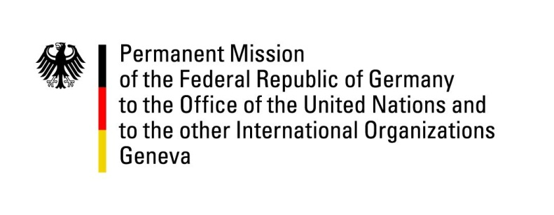

United Nations Human Rights Council

40th Session of the UPR Working Group

Geneva, 28th January 2022

German Recommendations and advance questions to

Lithuania

Mister President,

Germany welcomes the delegation of Lithuania to the UPR. Germany appreciates Lithuania’s steadfast commitment to the promotion and protection of human rights worldwide, especially but not only its active role in the Human Rights Council.

While domestic violence, particularly during the pandemic, remains an issue of concern in many countries, we commend Lithuania for recent efforts to effectively address domestic violence as well as for legislation allowing transgender people to change their name.

Germany recommends to:

- Strengthen efforts to fight all forms of discrimination against women and gender-based violence, including by ratifying the Istanbul Convention.

- Strengthen measures aimed at fighting discrimination against LGBTIQ persons and at preventing, investigating and punishing acts of discrimination and violence against them.

Thank you, Mister President.

GERMAN ADVANCE QUESTIONS TO Lithuania:
- How does Lithuania ensure the protection of LGBTI people from discrimination?

- Which measures does Lithuania take to ensure that the principle of non-refoulement is respected at all times and vulnerable persons are identified at the earliest possible stage with regard to the irregular border crossings from Belarus? Which efforts does Lithuania make to integrate migrants, asylum seekers and refugees?

