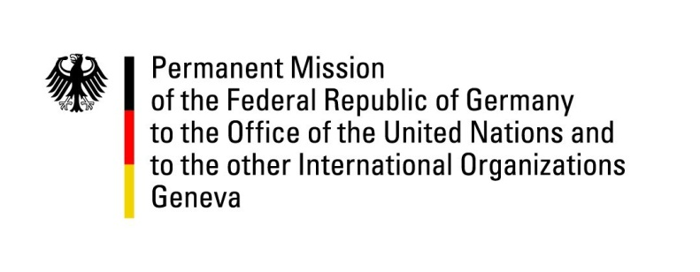

United Nations Human Rights Council

40th Session of the UPR Working Group

Geneva, 25th of January 2022

German Recommendations and advance questions to
Iceland

Mister President,
Germany commends Iceland’s steadfast commitment to the promotion and protection of human rights worldwide, the positive human rights situation in Iceland and its strong efforts in promoting non-discrimination in relation to sexual orientation and gender identity. Germany also commends Iceland´s decision to accede to the Convention on the Reduction of Statelessness.

Germany recommends to:
- Establish a National Human Rights Institution, in accordance with the Paris Principles, following a respective announcement of Iceland´s government, which we welcome;
- Take further positive steps in relation to women´s rights, in particular by strengthening state prosecutors´ and police officers´ capabilities to investigate gender-based sexual violence and by adopting a new action plan against sexual violence;
- To ensure that its courts implement its new whistle-blowing legislation firmly to prevent attempts of intimidation against journalists and whistle-blowers by private persons.

Thank you.

