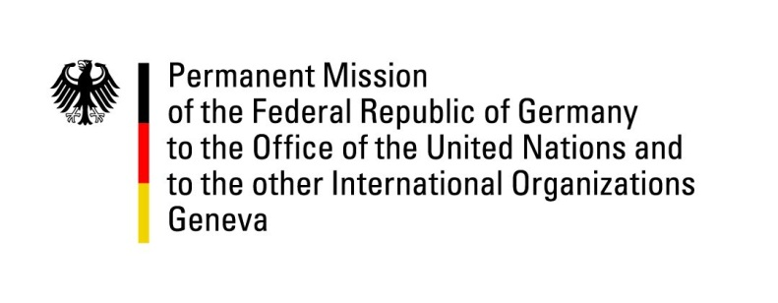

United Nations Human Rights Council

40th Session of the UPR Working Group

Geneva, 31st of January 2022

German Recommendations and advance questions to

Haiti

Mister President,

Germany welcomes the delegation of Haiti. Germany remains seriously concerned about the security situation in Haiti, which adds to the exorbitant challenges following the assassination of President Moïse and the earthquake of August 2021.

We commend the Haitian authorities for their efforts in safeguarding the health and the lives of citizens. Germany remains alarmed, however, about widespread impunity, particularly regarding cases of sexual and gender-based violence
Germany therefore recommends to:

- Ensure sufficient budgetary means to maintain adequate human resources in the Haitian National Police
- Ensure sufficient human resources in the judicial system to enable it to operate independently and guarantee the right to a fair trial.
- Create efficient remedies for female victims of sexual and domestic violence, including by establishing specialized police officers and prosecutors and by establishing adequate preventive and protective measures for victims

Thank you Mister President.

Advance questions to Haiti

- In 2016, Germany recommended to end all enforced evictions from displacement camps and establish an official moratorium on mass evictions until all legal and procedural safeguards compliant with international human rights standards are in place. We would be interested to learn what concrete measures Haitian authorities have undertaken following this recommendation.
- Germany would be keen to know when the government will set in motion the 2019 Action Plan on Human Rights and which steps the Haitian authorities will take in 2022 and 2023 to implement it.

