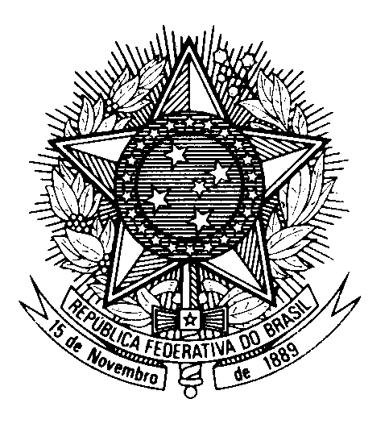

Statement of BRAZIL

40th session of the 3rd cycle of the Universal Periodic Review of Sudan

(Geneva, 1st February 2022)

Brazil welcomes Sudan to the UPR.

Brazil expresses its concern with the ongoing crisis, which has undermined progress achieved by Sudan and its people in the last few years.

We encourage Sudan to strengthen initiatives to promote equality, fight discrimination and intolerance, and expand political participation.

We acknowledge reports on the adoption of amendments to the Criminal Code of 1991 and call upon the country to enact additional reforms to improve compliance with international human rights law, in particular as regards the imposition of the death penalty.

Brazil makes the following recommendations:

(1) To fully implement the resolution of the 32nd Special Session of the HRC, including with regards to an independent mechanism to support the Sudanese people`s aspiration for democracy and the rule of law;

(2) To take steps to strengthen the respect to the rights to freedom of expression and peaceful assembly and to ensure accountability for all violations against peaceful protesters.

Thank you.

