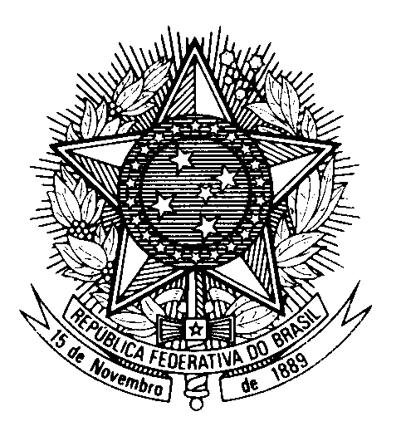

STATEMENT OF BRAZIL

40th Session of the 3rd cycle of the Universal Periodic Review of South Sudan

(Geneva, 31st January, 2022)

Mr. President,

Brazil welcomes the delegation of South Sudan to the UPR.

We note progress regarding the implementation of the 2018 Revitalized Agreement, including the appointment of a new national Parliament with representatives of all political forces and of legislative assemblies in most states.

We are also aware of efforts to overcome impunity for human rights violations, through institutional reforms in the security sector.

Brazil remains concerned by the lack of ratification of core international human rights instruments and invites South Sudan to consider ratifying the CED and the CRPD.

In a constructive spirit, Brazil recommends South Sudan to:

1. Adopt additional preventive measures to cease all violations of international and humanitarian law, particularly regarding intercommunal and gender violence, and to ensure prompt and impartial investigations of such violations.

2. Consider abolishing the death penalty or implementing a moratorium on its application.

Moreover, we encourage South Sudan to continue its efforts to fully implement the 2018 Peace Agreement.

Thank you.

