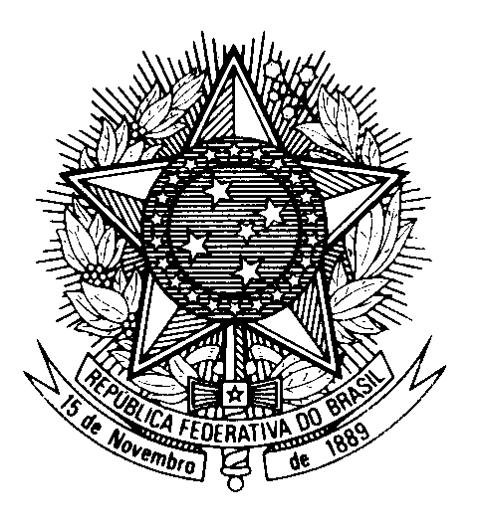

Statement by Ambassador Tovar da Silva Nunes,

Permanent Representative of Brazil to the United Nations Office,

in the review of Moldova, during the 40th session of the Working Group

on the Universal Periodic Review

(Geneva, 28 January 2022)

Brazil welcomes the delegation of the Republic of Moldova to the third cycle of the UPR.
We commend advances in the establishment of human rights institutions, including the National Human Rights Council, the Office of the People´s Advocate and the Council for Preventing and Eliminating Discrimination and Ensuring Equality. We also appreciate the ratification of the Optional Protocol to the CRPD and the series of measures to ensure social protection during the COVID-19 pandemic.
In a constructive spirit, Brazil recommends that the Republic of Moldova:
1) Adopt additional measures to reduce the incidence of maternal and child mortality, as well as to ensure that all births are registered; and
2) Expedite the development of a strategy for the de-institutionalization of persons with mental and intellectual disabilities, in accordance to the UN Convention on the Rights of Persons with Disabilities.
We encourage Moldova to take concrete measures to eliminate stigmatization of and discrimination against persons living with HIV.
Thank you.

