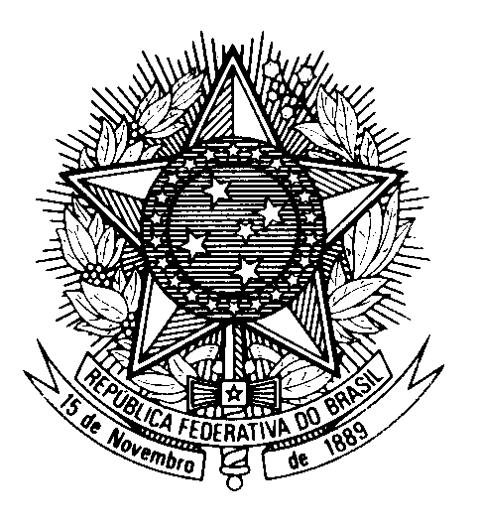

STATEMENT OF BRAZIL

40th Session of the 3rd cycle of the Universal Periodic Review of Uganda

(Geneva, 27th January, 2022)

Mr. President,

Brazil welcomes Uganda to the UPR.

We praise Uganda's commitment to mainstreaming human rights into the implementation of the 2030 Agenda.

We also commend the recent adoptions of the Mental Health Act, the Persons with Disabilities Act, and the Prevention and Prohibition of Human Sacrifice Act.

Brazil remains concerned with the criminalization of same-sex relations and discrimination against LGBTI persons, as raised in our second-cycle recommendations.
We strongly encourage Uganda to Ratify the OPCAT and the Second Optional Protocol to the ICCPR, aiming at the abolition of the death penalty. Brazil invites Uganda to strengthen the implementation of the Female Genital Mutilation Act.

Also Brazil makes the following two recommendations:
1) ensure equal rights for women and men in all domains, including marriage, divorce, inheritance, and employment;
2) adopt national legislation protecting children from statelessness and ratify the Convention on the Reduction of Statelessness.

Brazil wishes Uganda a successful review.

Thank you.

