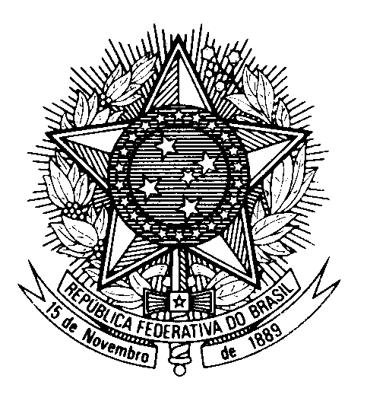

Statement by Ambassador Tovar da Silva Nunes,

Permanent Representative of Brazil to the United Nations Office,

in the review of Lithuania, during the 40th session of the Working Group

on the Universal Periodic Review

(Geneva, 26 January 2022)

Brazil welcomes the delegation of Lithuania to the UPR.
We commend the adoption of measures aimed at the protection of the rights of the child, including legislation on the prohibition of all forms of violence against the child, as well as advances in the promotion of social integration of persons with disabilities, including funds for monitoring the UN Convention on the matter.
In a constructive spirit, Brazil makes the following two recommendations:
1) Take concrete measures to guarantee that vulnerable groups, particularly Roma, have access to adequate health care;
2) Reinforce the antidiscrimination provisions in its Law on Equal Treatment and Criminal Code, including by expressly forbidding discrimination on the basis of "colour" or "descent".
We express concern over reports of intolerance towards vulnerable and minority groups, and encourage the country to combat discrimination and prevent hate speech. We invite Lithuania to strengthen the legal framework for the protection of women against violence, including by criminalizing marital rape.
Thank you!

