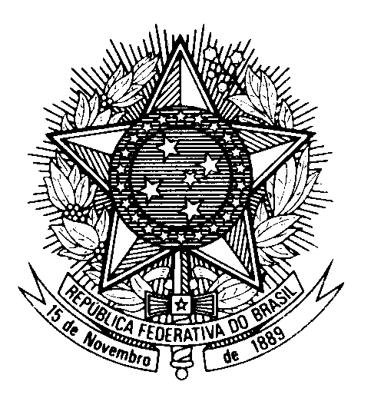

Statement of BRAZIL

40th session of the 3rd cycle of the Universal Periodic Review of Iceland

(Geneva, 25 January 2022)

Mr. President,

Brazil welcomes the delegation of Iceland to this third UPR cycle.

We welcome Iceland`s accession to the Convention on the Rights of Persons with Disabilities, as well as to the Optional Protocol to the Convention Against Torture, as recommended by Brazil in the second cycle.

We invite the country to ratify the International Convention for the Protection of All Persons from Enforced Disappearance.

While congratulating the country on the anti-discrimination acts on Equal Treatment irrespective of Racial and Ethnic origin and on Equal Treatment in the Labour Market, we encourage Iceland to take measures to ensure the full and effective implementation of existing legal provisions prohibiting racial discrimination, to facilitate effective access to justice and to provide appropriate remedies for all victims of racial discrimination.

We further praise the adoption of the 2020 Act on Equal Status and Equal Rights Irrespective of Gender.

With a constructive spirit, Brazil recommends that Iceland:

1) improves measures to combat gender and domestic violence, so as to ensure adequate investigation and prosecution of reported abuses and violations against women and children; and

2) takes additional steps towards addressing the unemployment rate among migrants, as well as towards improving access to secondary education for children with immigrants backgrounds.

We wish Iceland a successful review.

Thank you.

