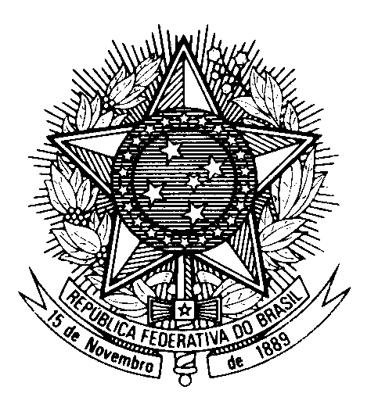

Statement by Ambassador Tovar da Silva Nunes,

Permanent Representative of Brazil to the United Nations Office,

in the review of Syria, during the 40th session of the Working Group

on the Universal Periodic Review

(Geneva, 24 January 2022)

Brazil welcomes Syria to the UPR.
Despite challenges, we note progress since the last review, including the Child Rights Act; the elimination of discriminatory provisions in the Criminal Code and the Personal Status Act; and efforts to facilitate safe and voluntary returns.
We also acknowledge measures to repair social infrastructure such as hospitals and medical centers, especially in the context of the Covid-19 pandemic.
Brazil remains, nonetheless, concerned by the severe impacts of the Syrian conflict on the human rights and humanitarian situation of its people.
With a constructive spirit, Brazil recommends Syria to:
1) ratify the Optional Protocol to ICCPR on the abolition of the Death Penalty and the Convention against Enforced Disappearances;
2) engage with the Commission of Inquiry and facilitate its unhindered access to its territory;
We encourage Syria to ensure equal rights to women and men in transmitting their nationality to their children, to prevent statelessness.
Brazil also invites the Syrian government and the Constitutional Committee to exercise further spirit of compromise in support of a timely, effective, Syrian-owned and Syrian-led political solution, rooted on human rights.
Thank you!

