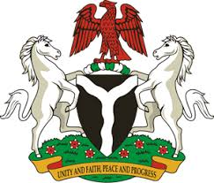
Please check against delivery
HUMAN RIGHTS COUNCIL
40TH SESSION OF THE WORKING GROUP OF THE UPR
REVIEW OF ICELAND
25TH JANUARY, 2022
STATEMENT BY NIGERIA
Mr President,
Nigeria welcomes the delegation of the Republic of Iceland to the presentation of its National Report for the Third Cycle UPR and commends the Government for its cooperation with human rights mechanisms and efforts in the implementation of previous recommendations.
2. We applaud the Government of Iceland for its commitment to the promotion and protection of human rights and fundamental freedoms. Nigeria also notes, with encouragement, the initiative titled ‘Emphases on Actions to Combat Human Trafficking and Other Forms of Exploitation’ issued by the Government of Iceland in 2019.
3. In the spirit of constructive dialogue, Nigeria wishes to recommend to the Government of Iceland as follows:
- To strengthen effort to ensure the protection of the rights of migrant workers and members of their families; and
- To continue to pursue all efforts to combat human trafficking, as well as the protection of the rights of victims of human trafficking.
4. In conclusion, Nigeria wishes Iceland a very successful review process.
I thank you Mr President.
******

